**Project Development phase**

**Project Development delivery of sprint 1**

|  |  |
| --- | --- |
| Team ID | PNT2022TMID50823 |
| Project name | Smart crop protection system for agriculture |

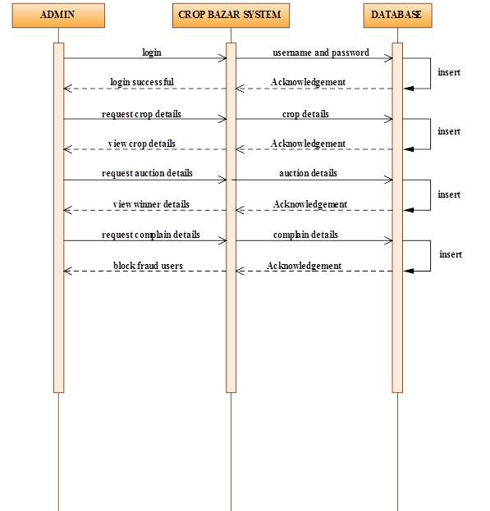

**Coding:**

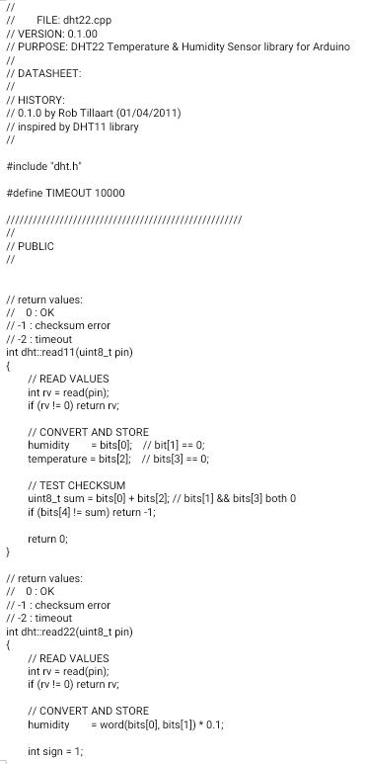

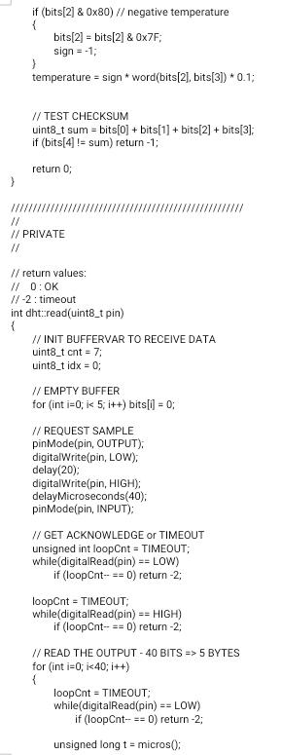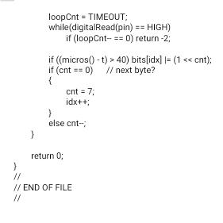

**Software required:**

XML & Java

**System required:**

RAM-minimum 4gb processor-Min. Configuration OS-Windows/Linux/Mac